केद्रीय विद्यालय रानीखेत
Monthly Test-July 2025 Class-12 Mathematics
TIME: 90 Min M.M.:40
General Instructions: All questions are compulsory.

Q.No. | SECTION-A(1 Mark each) | Marks
 | Find the antiderivative of $e^{-2x}.$ | 1
 | Find the value of $\int_{-1}^{1}{\frac{\left|x\right|}{x}dx},x≠0$. | 1
 | Find the area bounded by the curve $y=sinx$ and the x-axis between $x=0 and x=2π$. | 1
 | ASSERTION:$\int{e^{x}\left(cosx-sinx \right)dx= e^{x}\cos{x+c }}$  REASON:$\int{e^{x}\left(f\left(x\right)+f^{'}\left(x\right)\right)dx=e^{x}f\left(x\right)+c}$  - Both A and R are true and R is correct explanation of A  - Both A and R are true and R is not correct explanation of A  - A is true but R is false  - A is false but R is true | 1
Q.No. | SECTION-B (2 Mark each) | Marks
 | Find the value of $\int_{0}^{1}{\frac{1}{e^{x}+e^{-x}}dx}$ | 2
 | Calculate the area of the region bounded by the curve $\frac{x^{2}}{9}+\frac{y^{2}}{4}=1$and x-axis by integration. | 2
 | Find the value of $\int_{0}^{1}{x}{(1-x)}^{n}dx$ | 2
 | If $\int_{0}^{a}{3x^{2}dx=8,}$then find the value of a. | 2
 | Find $\int{x\sqrt{1+2x}}dx.$ | 2
Q.No. | SECTION-C(3 Mark each) | Marks
 | Find the area of the region bounded by the curves $y^{2}=x and x=4 and x-axis$in first quadrant. | 3
 | Find $\int{\frac{x+\sin{x}}{1+\cos{x}}dx}$ | 3
 | Evaluate:$\int_{1}^{4}{\left(\left|x-2\right|+\left|x-4\right|\right)dx}$ | 3
 | Evaluate: $\int{\frac{sin⁡x}{(1-\cos{x)}(2-\cos{x})}}dx$ | 3
Q.No. | SECTION-D (5 Mark each) | Marks
 | Evaluate $\int_{0}^{\frac{π}{2}}{\frac{x\sin{x\cos{x }}}{\sin^{4}x+\cos^{4}x}}$dx  OR  Evaluate $\int_{0}^{\frac{π}{2}}{[\log{\sin{x-log⁡(2\cos{x)] dx }}}}$ | 5
 | (CBQ)A woman discovered a scratch along a straight line on a circular table top of radius 8 cm. She divided the table top into 4 equal quadrants and discovered the scratch passing through the origin inclined at an angle of $\frac{π}{4}$ anticlockwise along the positive direction of x-axis. Find the area of the region enclosed by the x-axis, the scratch and the circular table top in the first quadrant, using integration | 5
 | CASE STUDY
 | A child cuts a pizza with a knife. Pizza is circular in shape which is represented by $x^{2}+y^{2}=4$ and sharp edges of the knife represents a straight line given by $x=\sqrt{3} y$.  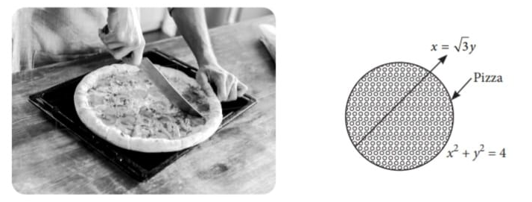  Based on the above information answer the following questions  (i) Find the point of intersection of line and pizza as shown in the figure.  (ii) Write the expression for the area bounded by the circular pizza and the edge of the knife in the first quadrant.  (iii) Find the area of the region bounded by the circular pizza and the edge of the knife in the first quadrant. | 1  1  2

